7.1.6 RAIN WATER HARVESTING STRUCTURES AND UTILIZATION IN THE CAMPUS (1)

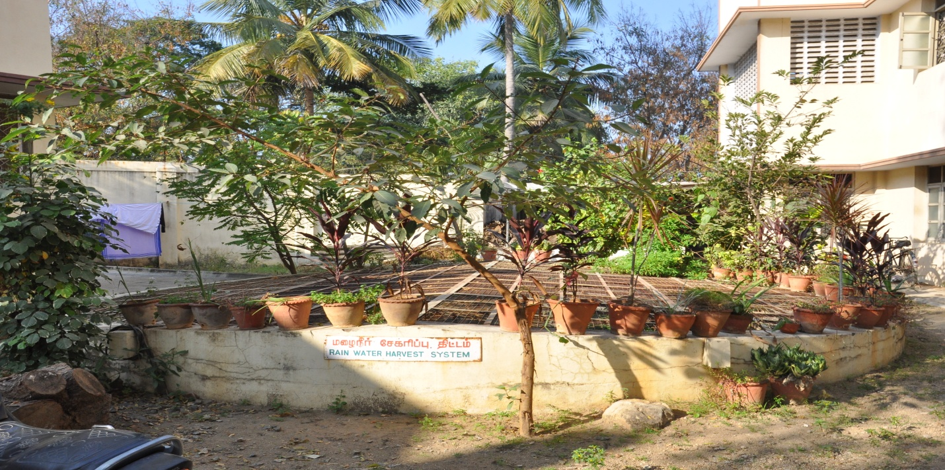
Rain Water Harvesting Tank near Amalagam Hostel

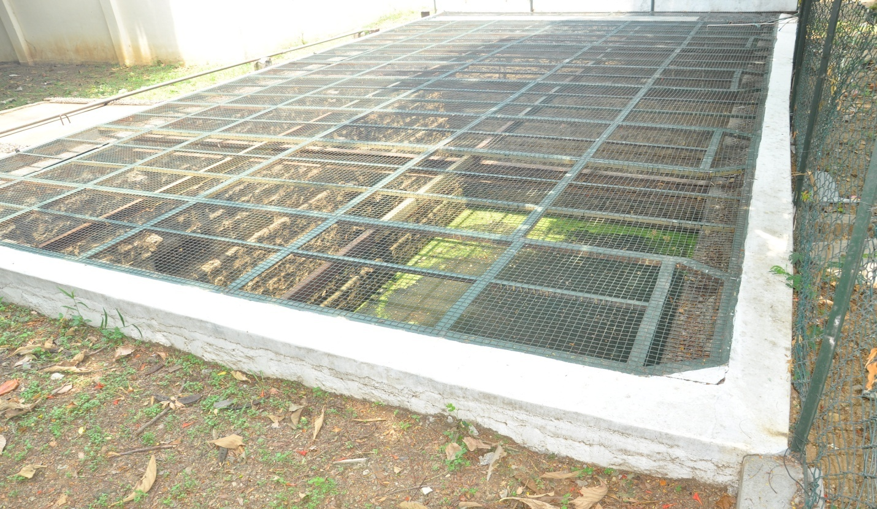
Rain Water Harvesting Tank near DBIS

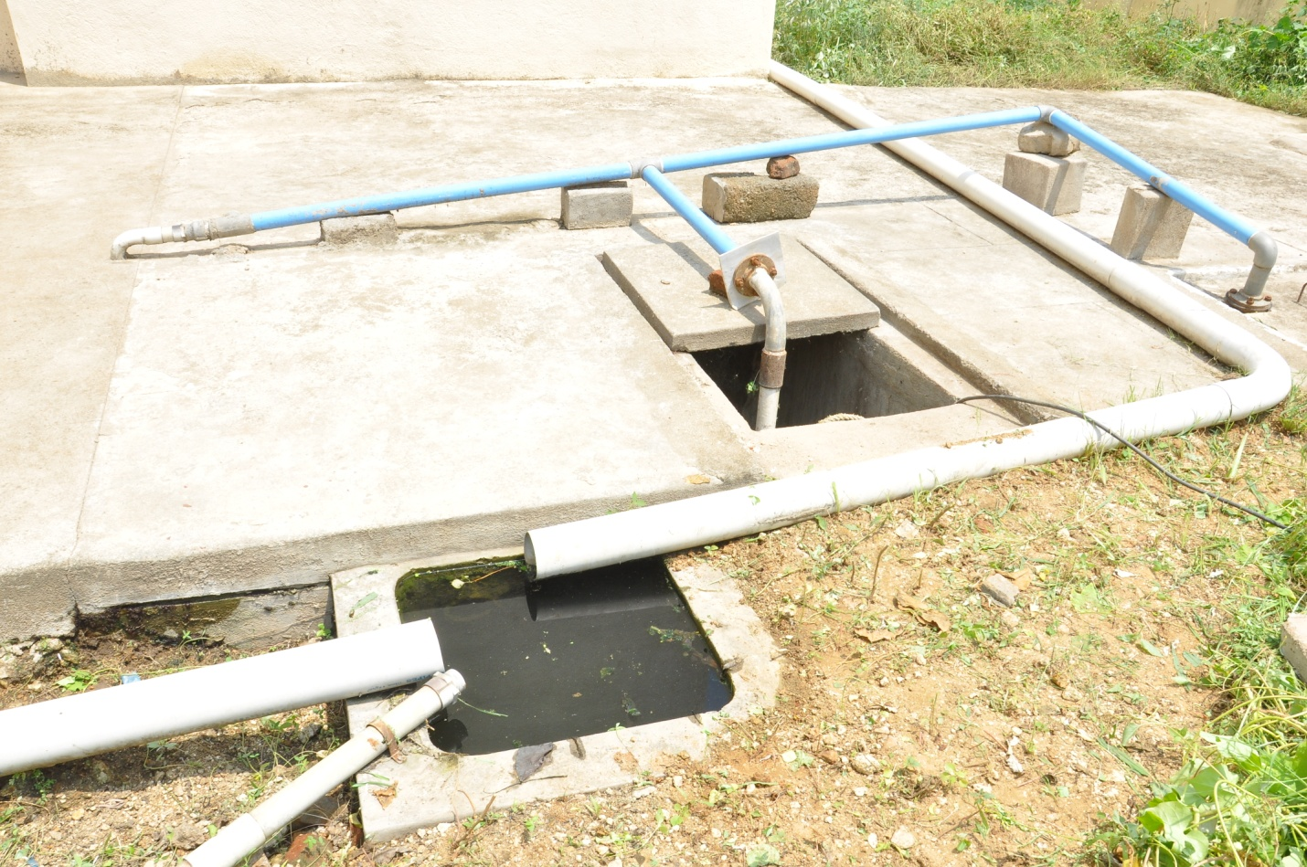
Rain Water Harvesting Tank near John Med Block

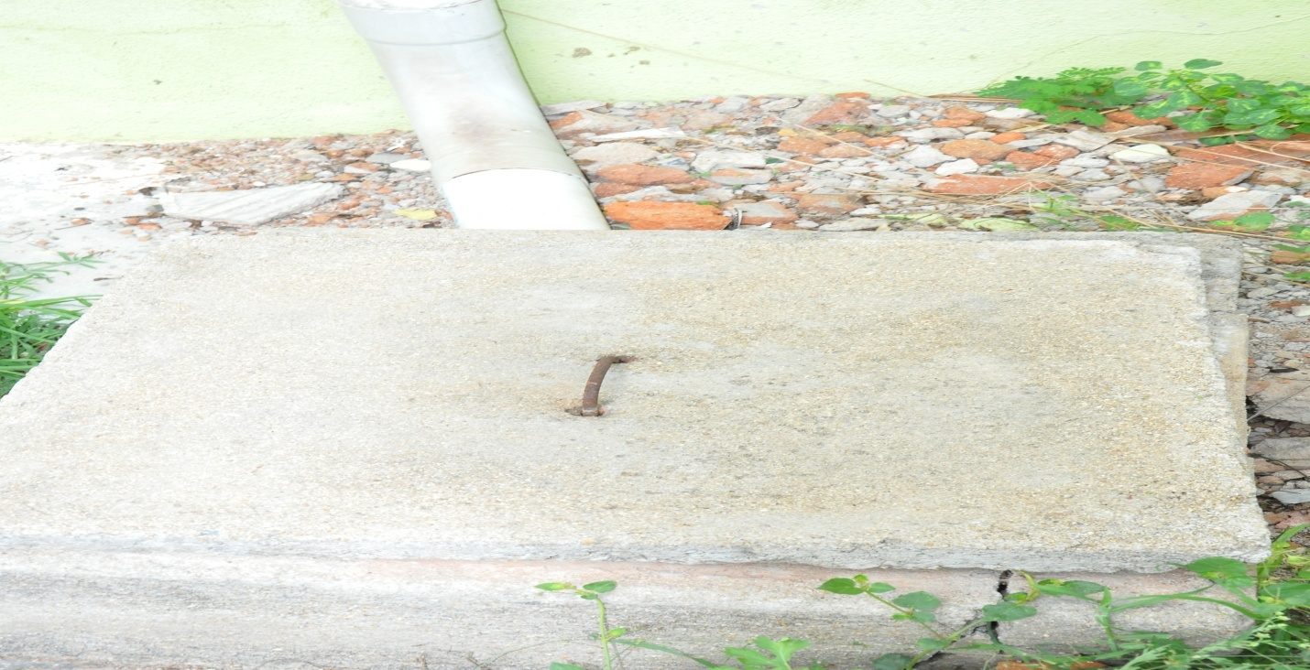
Rain Water Harvesting Tank near Silver Jubilee Block

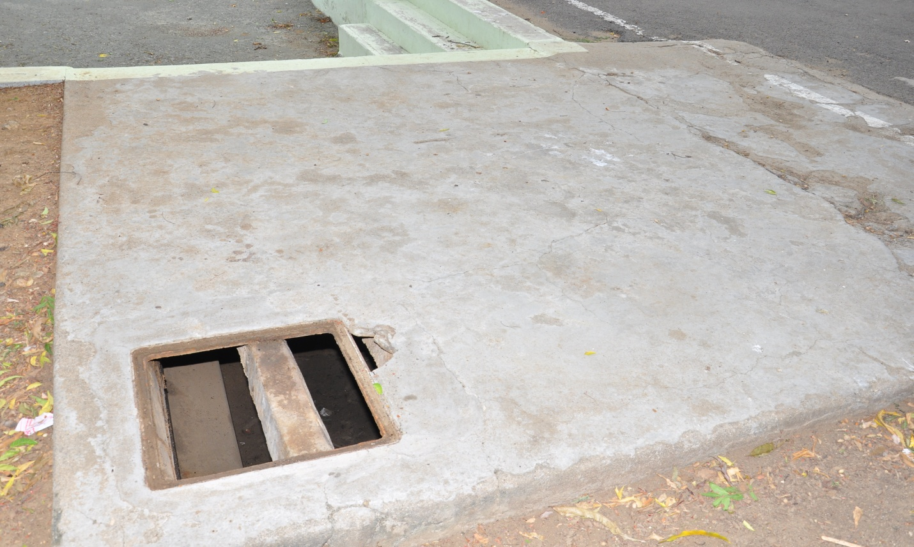
Rain Water Harvesting Tank near Volley Ball Ground

